**API Testing: Application Program Interface**

It is way of communication between 2 applications where application may differ in their platforms or in terms of technology.

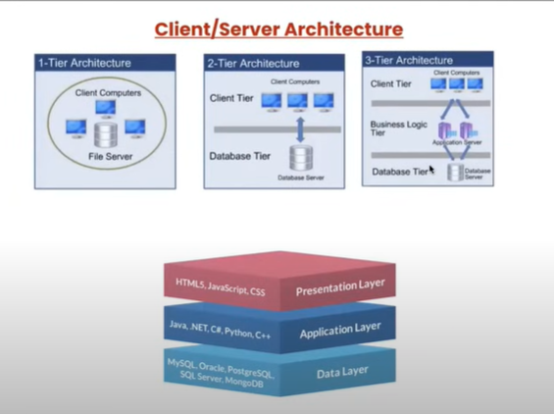

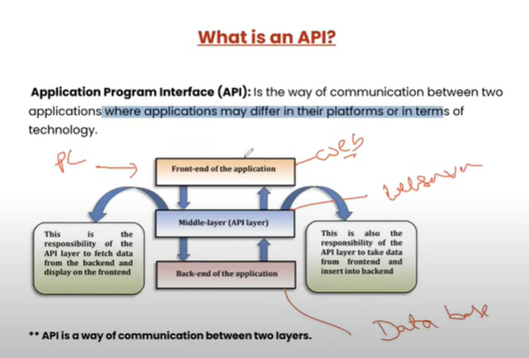

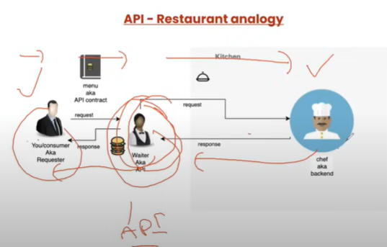

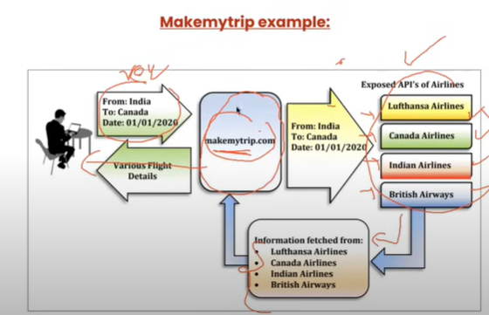

**Types of API:**

There re 2 types of API’s.

1. Simple Object Access Protocol (SOAP).
2. REST (Representation State Transfer).

Both are the web services.

SOAP => used by old applications.

REST => used by new/current applications.

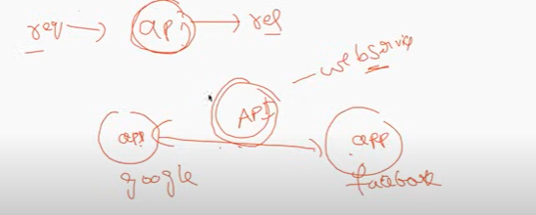

All Web Services are API. But all API are not Web Service.

When API is put in internet then it is called as Web Service.

For development & testing we use Api. And once its available to public over internet its called Webservice.

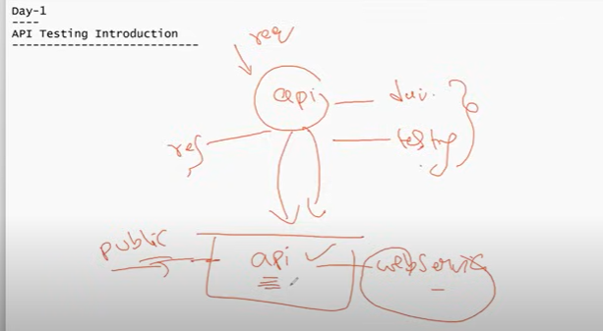

**Important: API Vs Webservice**

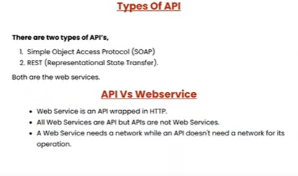

**Rest API methods:** http request

Get: we get data from the server.

Post: we are sending data to server to store.

Put: we can create/edit/update data in the server.

Delete: we delete the data from server.

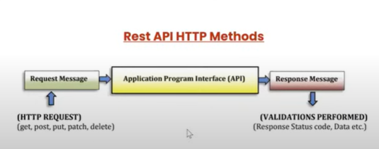

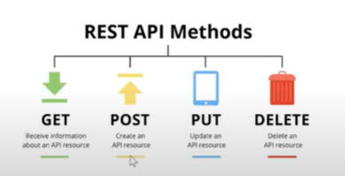

HTTP Vs HTTPS

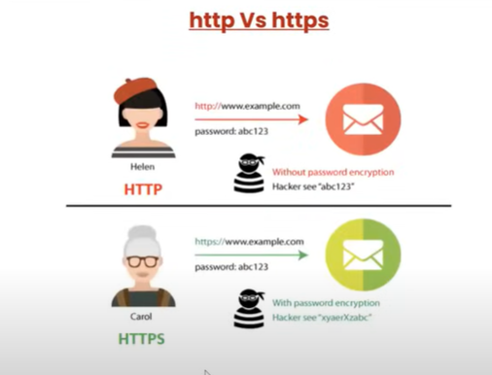

Terminology:

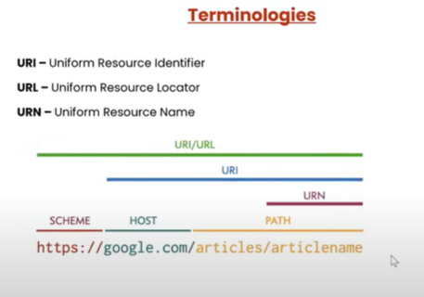

Payload:

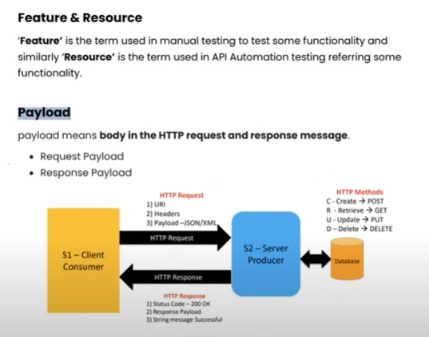

Ex: <https://reqres.in/>

Ex Get: <https://reqres.in/api/users?page=2> => <https://reqres.in/api/users?page=2>

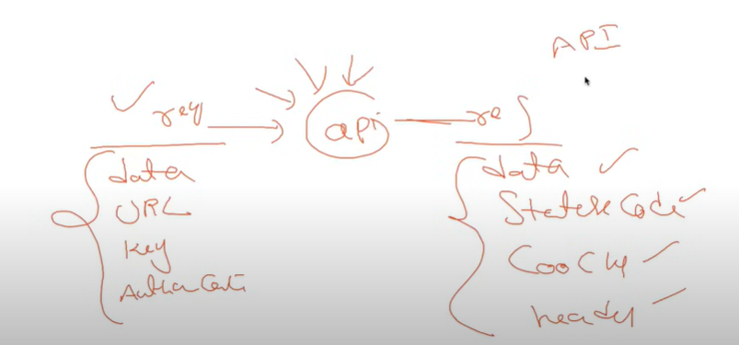

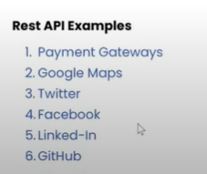

Postman – API testing

Desktop/web

Workspace: area where we maintain files and saved.

Workspace – create workspace, rename, delete.

Creating collection = contains number of folders and http requests. Create, rename, delete, run the collection.

We can create any number of collections under workspace.

Request ----🡪 API -------🡪 Response

http Request:

Get => retrieve the resource from database.

Post => create resource on database.

Put => update existing resource on database.

Patch => update partial details of resource.

Delete => delete existing resource from database.

Sample APIs: <https://reqres.in/>

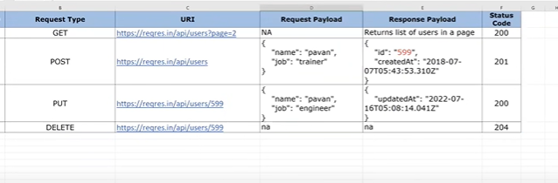

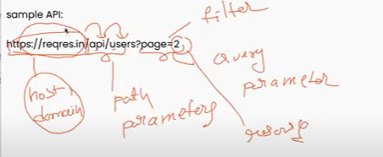

Validations:

1. Status code
2. Time
3. Size data
4. Response body(json/xml)
5. Cookies
6. Headers

HTTP Status code:

3 levels

1. 200
2. 400
3. 500

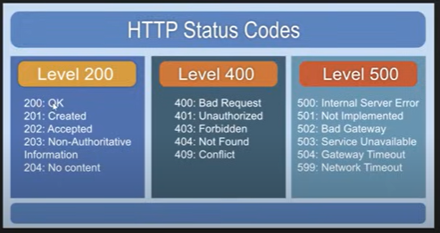

**How to create own API: JSON**

Create our own API’s

Steps:

1. NodeJS
2. Npm-node package manager

node - -version

npm --version

1. Json-server
2. Install json-server:

Run below command in cmd/terminal

npm install -g json-server

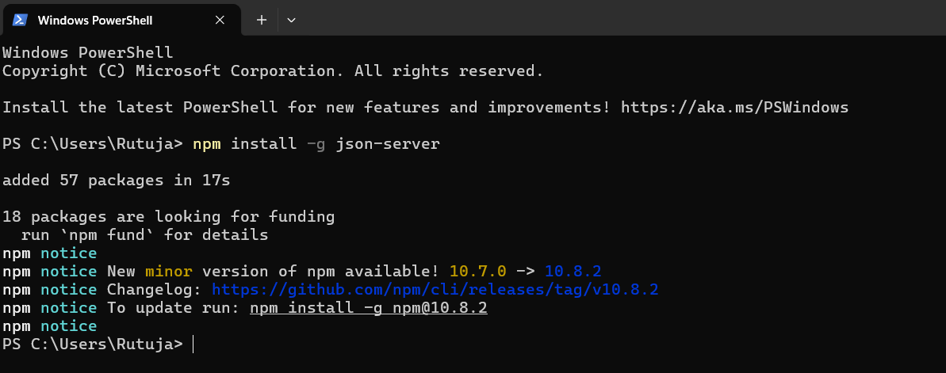

1. Create students.json file with following data.

{

    "students":[

        {

            "id": 1,

            "name": "John",

            "location": "India",

            "phone": "1234567890",

            "courses": [

                "Java",

                "Selenium"

            ]

        },

        {

            "id": 2,

            "name": "Kim",

            "location": "US",

            "phone": "2345678901",

            "courses": [

                "Python",

                "Appium"

            ]

        },

        {

            "id": 3,

            "name": "Smith",

            "location": "Canada",

            "phone": "3456789012",

            "courses": [

                "C#",

                "RestAPI"

            ]

        }

]

}

1. Run using command ‘json-server students.json’

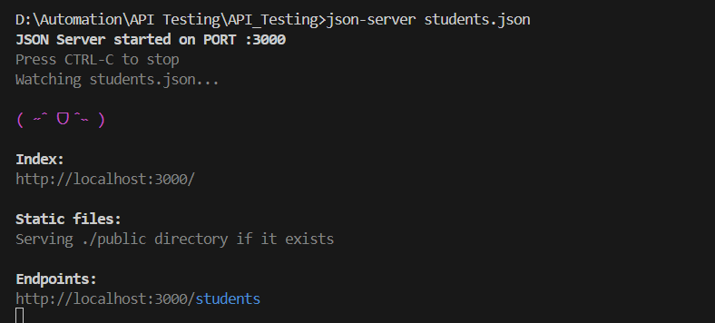

1. <http://localhost:3000/students> 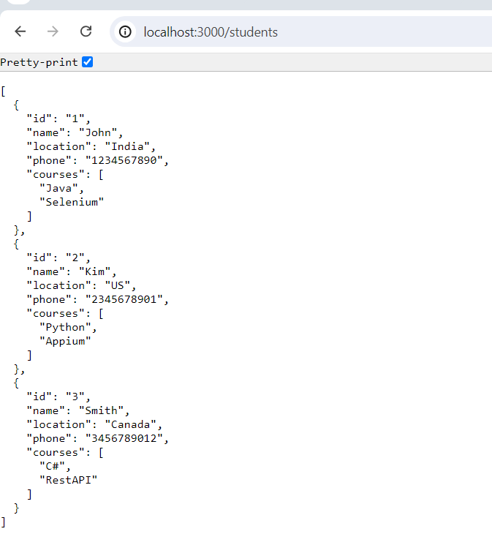
2. 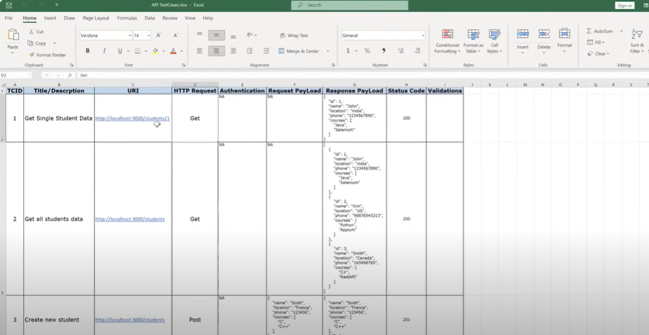

**JSON: Java Script Object Notation**

Key value pair

Key: value

**JSON Data Types:**

1. Number
2. String
3. Boolean
4. Null
5. Object
6. Array

{

“name”: “John”

}

**Data Types:**

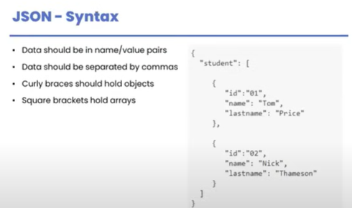

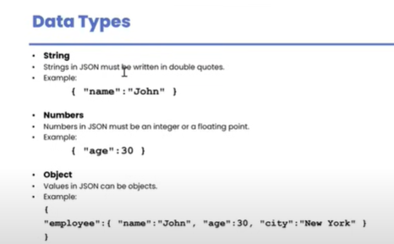

Key is always included in “ “ quotations.

{

“firstname”:”John”,

“secondname”:null,

“age”:30,

“phone”:[12345,67890],

“status”:true

}

Eg: Student data

Student – sid, sname, grad

{

“students”:[

{

“sid”=101,

“sname”=”John”,

“grad”=”A”

},

{

“sid”=102,

“sname”=”Mark”,

“grad”=”B”

}

]

}

JSON Path:

students[0].sname --🡪 John

students[1].sid ---🡪102

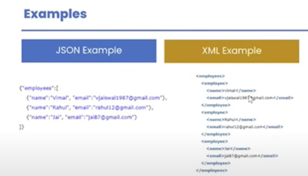

**JSON Object & JSON Array:**

**JSON Object:**

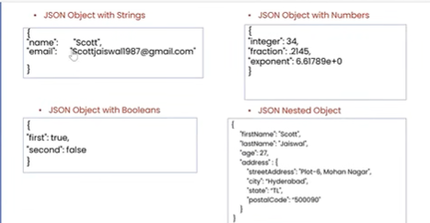

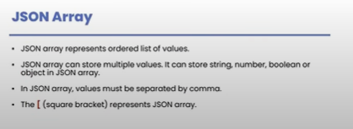

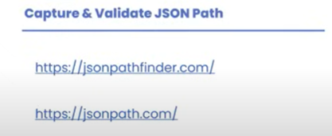

**JSON Path Finder:** [**https://jsonpathfinder.com/**](https://jsonpathfinder.com/)

**JSON Path Verify:** [**https://jsonpath.com/**](https://jsonpath.com/)

**API Response Validation | Different types of Assertions:**

**Response Validation:**

1. **Status code**
2. **Headers**
3. **Cookies**
4. **Response time**
5. **Response body**

**Assertion – validation**

**Postman – library**

Functions: written in JavaScript

Function types/can be written in 2 ways:

1. Normal function: written using normal keyword i.e. function().
2. Arrow function: written using arrow i.e. () =>.

Library/Framework: Chai

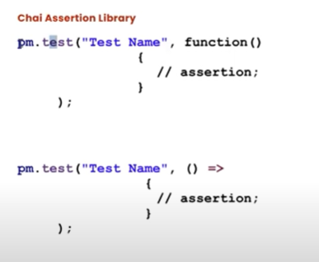

Here pm = postman.

**Testing Status Code:**

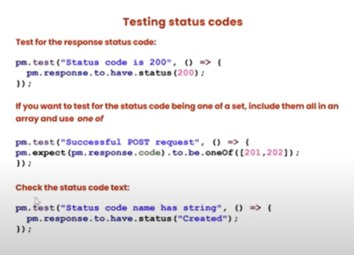

**Syntax:**

pm.test(“Test Name”, ()=>{

//assertion;

});

Ex:

pm.test(“Status code is 200”, () => {

pm.response.to.have.status(200);

});

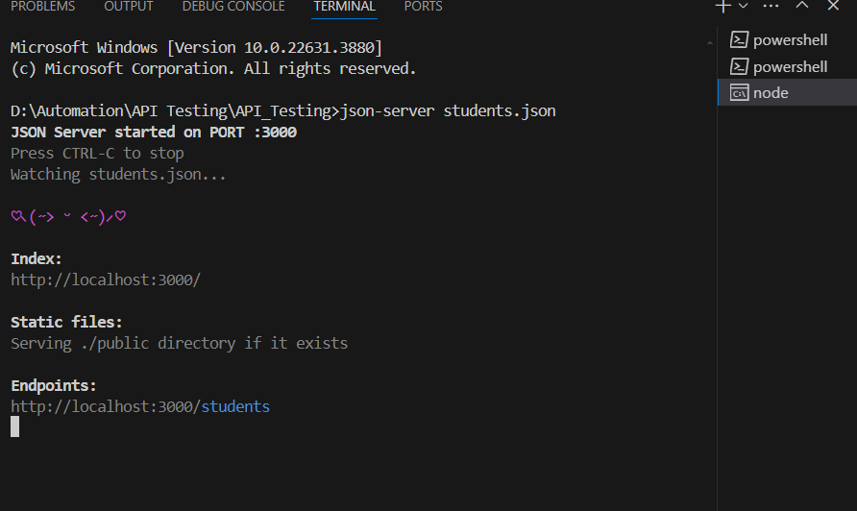

Postman:

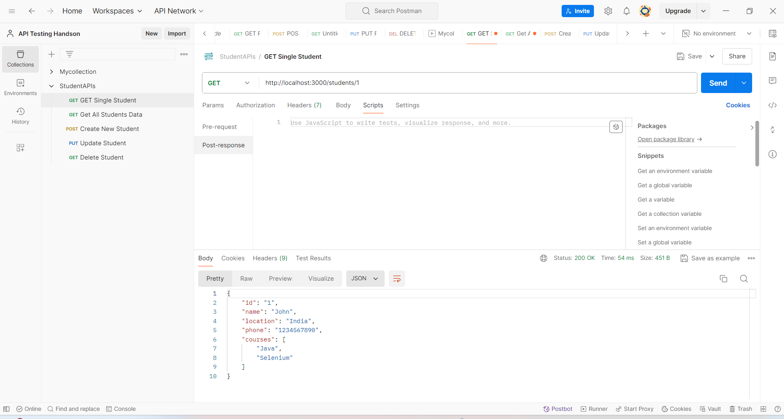

pm.**test**("Status code is 200", () **=>** {

    pm.response.to.have.status(200);

});

pm.**test**("Successful GET resquest", () **=>** {

    pm.expect(pm.response.code).to.be.oneOf([200,201]);

});

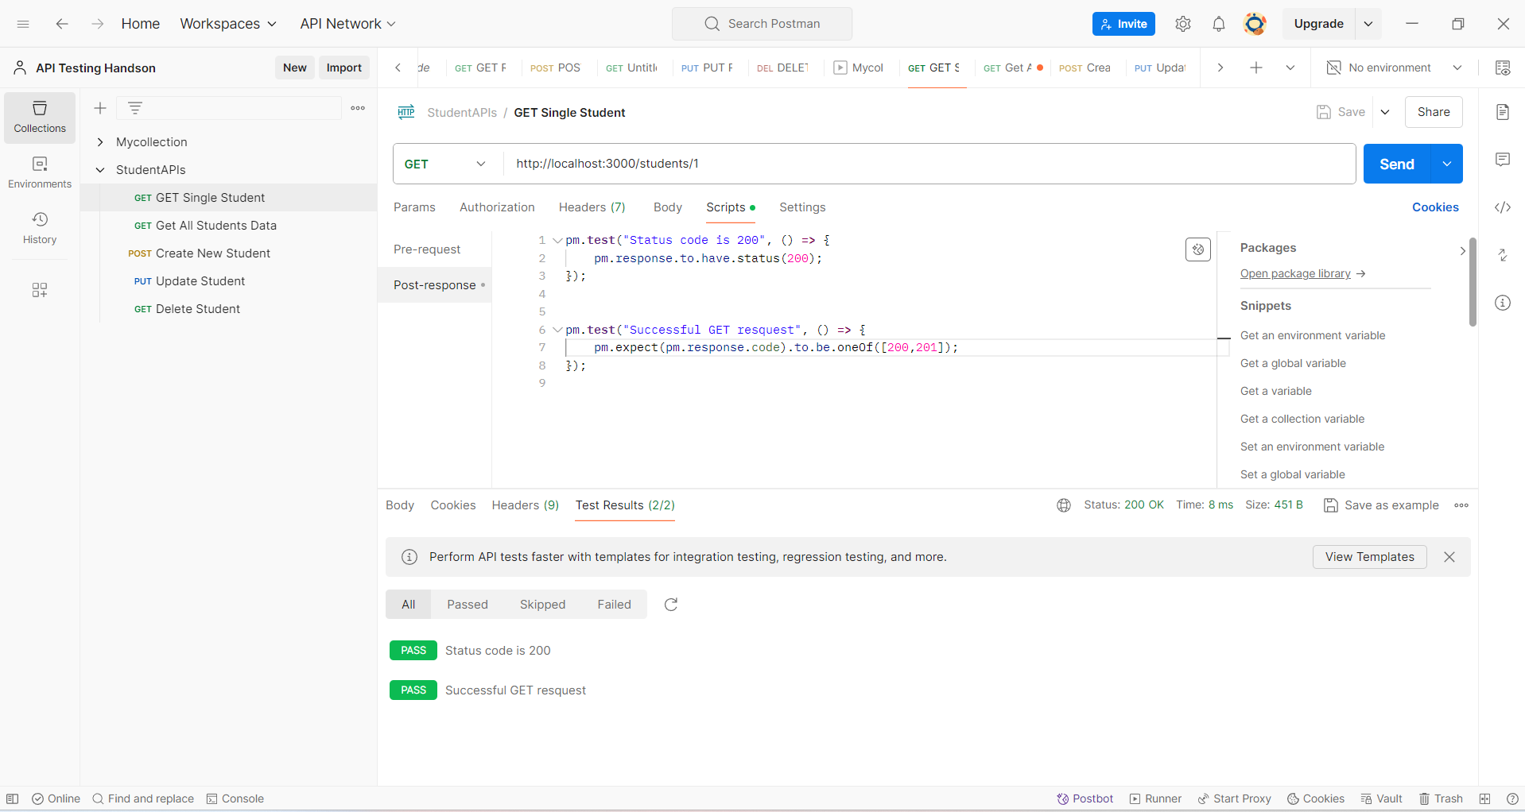

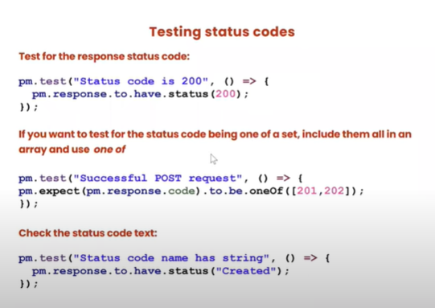

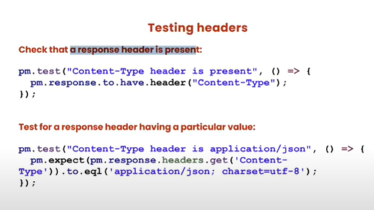

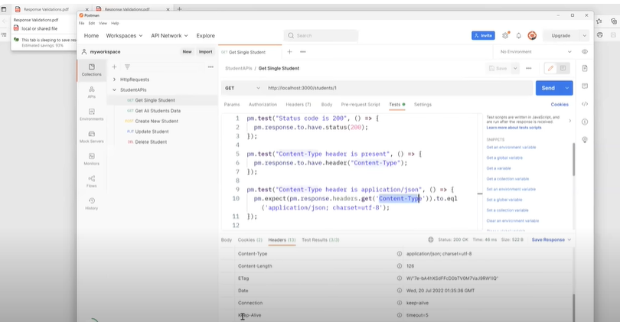

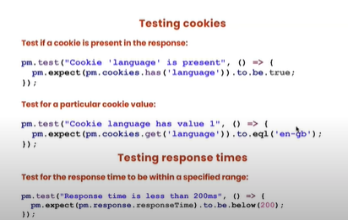

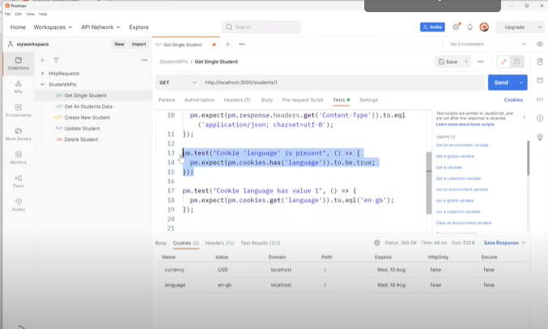

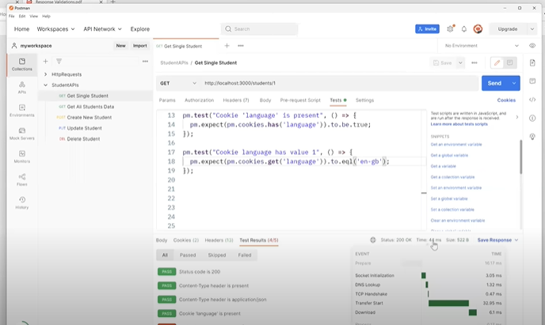

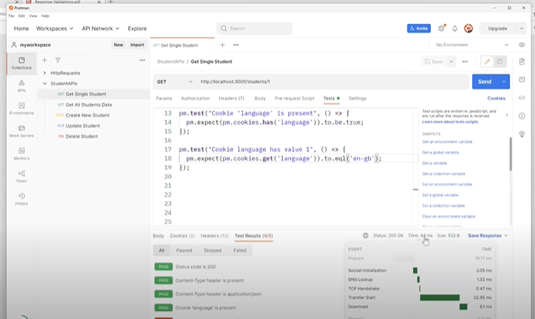

abcd